MASH Antifragile: Locked Specification
Oct 18, 2026 · @Neil Schwab
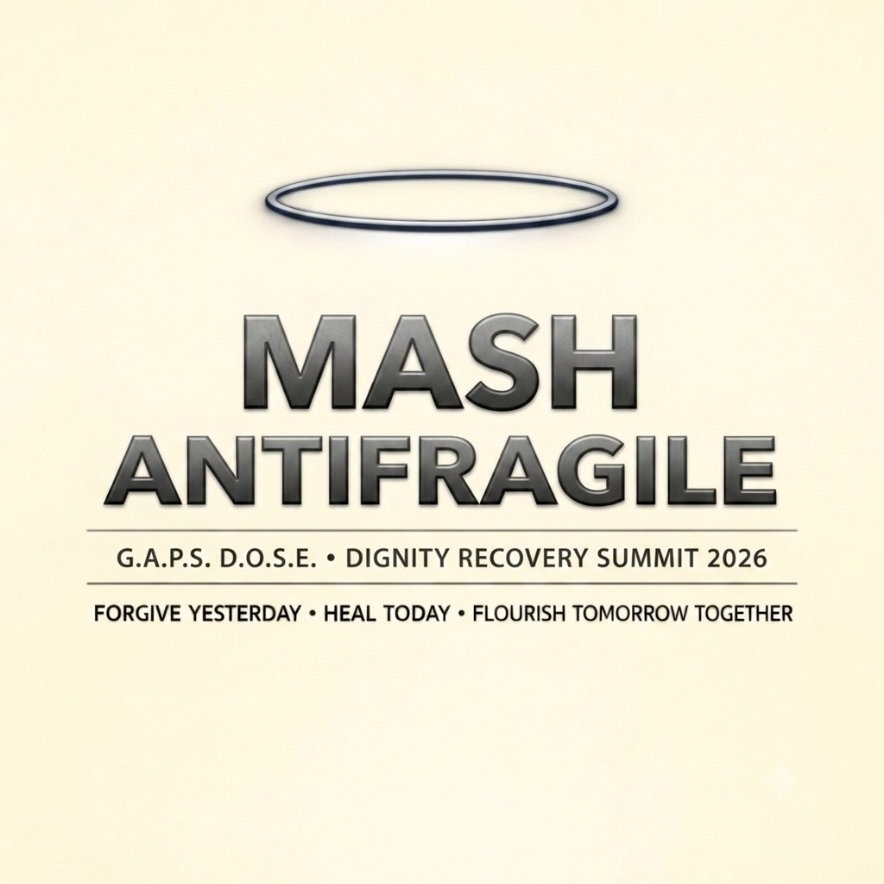

Core thesis
MASH teaches the nervous system what a safe, connected, purposeful life feels like, so a person comes to want that more than the drug. Addiction is a response to an environment; change the environment and you change what the person reaches for.
Most programmes discharge people after about 30 days, while post-acute withdrawal (PAWS) runs 6 to 24 months. MASH fills that gap with three months in a land-based community where belonging, mastery, rhythm and physical work are part of every day, not a weekly session. Every newcomer spends their first month shadowing a senior in that senior's final month, so the culture is handed down person to person.
The approach stands on established practice:
- Community Reinforcement Approach (Hunt and Azrin; later Meyers): make a sober life more rewarding than using. Its family version, CRAFT, matches the MASH family layer.
- Contingency management: tangible rewards for recovery behaviour, among the best-supported addiction interventions, especially for stimulants. The MASH points and games system is a form of it.
- Environment research: Alexander's "Rat Park" studies (around 1980) found isolated animals chose morphine far more than animals in an enriched social setting. Later replications were mixed, so it illustrates the idea rather than proving it.
The D.O.S.E. model (dopamine, oxytocin, serotonin, endorphins) is the framework's explanation of why connection, mastery, rhythm and movement work. It is an explanatory model, not a measured result.
MASH works alongside medical treatment, never instead of it. Medicine stabilizes the body; MASH changes the need.

Who MASH is for
MASH serves adults whose lives are cycling through emergency rooms, police contact and shelters, because that is where both the human need and the public cost are concentrated.
Eligibility (proposed).
- Age 18 or older
- Homeless, unstably housed or cycling through institutions for 12 months or more
- Two or more in the past year: emergency department visits, police or court contact, shelter use, or a failed discharge from treatment
- Medically stable enough for a non-clinical camp, or stabilized first through the medical partner
- Chooses to come: the Choice Point presents Path A and Path B honestly, and Path B is never assigned
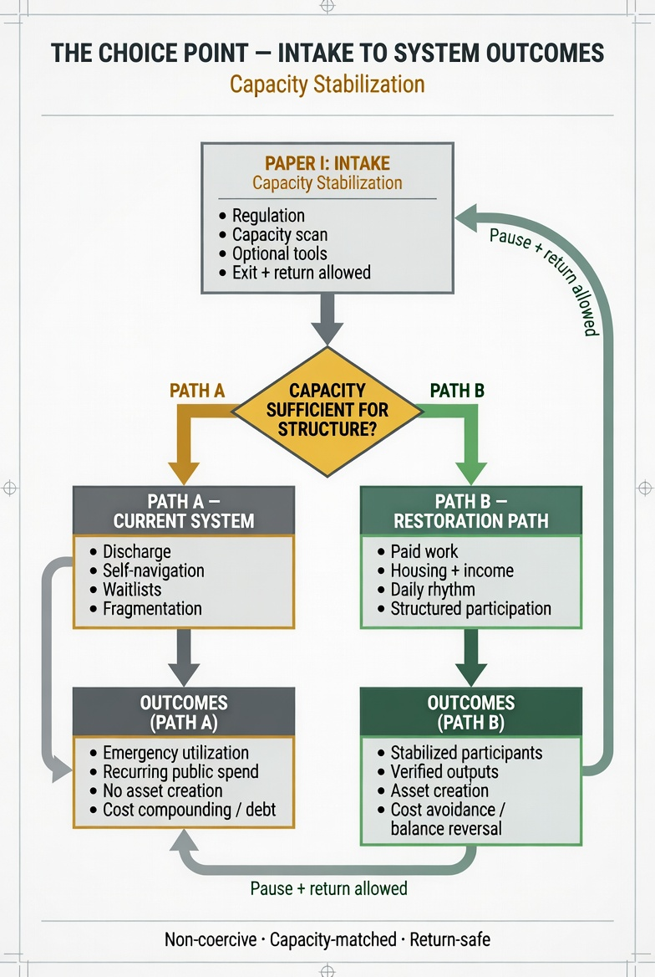
The Choice Point: non-coercive, matched to capacity, and safe to return to.
The screen matters to the savings case as well as to safety. The Housing First trial found the largest returns among the highest service users: $21.72 saved per $10 for the top 10% [At Home/Chez Soi]. The Conservative Floor in Section 8 is valid only for this group.
Not in scope for the pilot. People under 18; anyone needing hospital-level medical or psychiatric care; anyone ordered to attend as a court condition. People on parole or probation may still choose to come. A youth stream and court-ordered entry each need their own legal review before they are added.

The camp
One camp holds 200 residents in 20 nodes, with rolling intake so it stays full all year. Stays are three months, and returning participants are housed inside the same 200 beds.
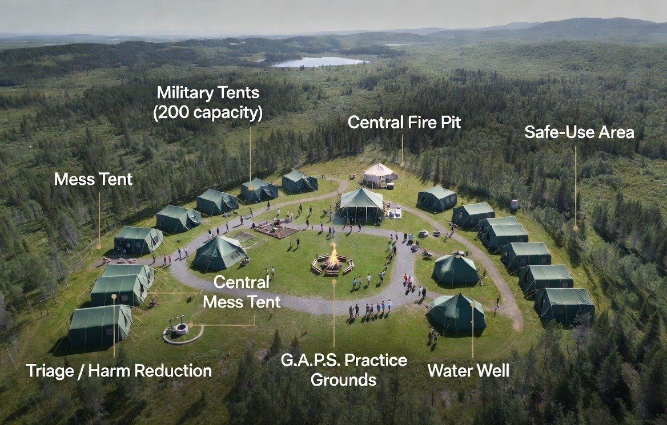
Concept rendering, not a real site photo.
Element | Specification
Core capacity | 200 residents in 20 tents
Node | 8 participants + 2 Controllers (peer mentors with lived experience)
Stay | 3 months (about 90 days); the newcomer's first month overlaps a senior's final month
Shadow pairing | Every newcomer is paired with one senior for their first month
Intake | Rolling, node by node: as a node graduates, a new node arrives
Throughput | About 600 people a year, plus about 525 short return stays
Site | Road access, flat ground, water (well), power (solar), kitchen, washrooms
Proposed location | Crown land near Cobalt / Coleman Township, or a donated or municipal site
Tents | Surplus Canadian Armed Forces tents, if released
Site criteria (from Enter the MASH). 40+ acres of flat or rolling ground with a slope for the mudslide. No open water on site (no river, lake or pond, to prevent drowning) and no cliffs. A well or piped water. Within 1 to 2 hours of a hospital and RAAM clinic; for Cobalt, that's Temiskaming Shores. Land held by the co-op or in trust so it can't be sold out from under the community.
Infrastructure.
- 20 military modular tents (10 people each), rated to −40°C, with propane heaters, CO detectors, solar lighting, cots, sleeping bags and lockable footlockers
- Mess tent with propane stoves and communal seating
- Triage and harm reduction tent (cot, lockbox, naloxone, medical supplies) and a separate User Area
- Central fire pit, never allowed to go cold during operating months
- Shower tent (propane-heated), outhouses built by residents, a well with hand pump and solar pump
- Activity area: heavy bag, drum logs, cleared ground for dancing and bingo, mudslide
- Optional chapel tent: non-denominational, quiet space
Why returns fit inside the camp. 200 beds × 365 days = 73,000 bed-days. 600 three-month stays use 54,000 and the 525 return stays a year (Section 8) use about 15,750, a total of 69,750, or about 96% full. No separate return node is needed, but there is little slack: if returns run higher than the halving cascade, the camp needs more beds or fewer first stays.
Controllers in Year 1. Controllers are meant to be graduates, but the first cohort has none. Year 1 needs hired peer support workers with lived experience, paid from the Operations stream. Budget warning: Operations is $2.25M a year at the 3-month stay. Forty peer workers at around $45,000 each would take about $1.8M of it, leaving little for the medical float, insurance and site. Year 1 may need one hired Controller per node (20) plus a graduate Controller from the first cohort, or Controller wages counted in Community & Elders. Settle this before the budget goes out (open decision 4).
Harm reduction and triage (as set out in Enter the MASH). Three spaces sit at the edge of the camp, each with a clear path back to triage:
- Triage Centre. Intake, RAFT assessment, medical screening and the 90-minute LLJ stabilization protocol.
- Harm Reduction Centre. PAWS symptom checks, naloxone training, wound care, safe consumption education and warm handoffs to RAAM.
- User Area. A separate, supervised space so no one uses alone, with sharps disposal and naloxone on the wall.
These spaces are peer-run by Controllers and graduates trained in first aid, naloxone and overdose response, with Neil as harm reduction lead. A mobile float team from the medical partner (CAMH or RAAM) provides the clinical cover and carries its own clinical insurance.
The User Area needs a legal route before it opens. Supervised consumption in Canada needs a federal exemption from Health Canada under section 56.1 of the Controlled Drugs and Substances Act. Ontario's 2024 Community Care and Recovery Act also restricts consumption sites, and the province has been moving funding to HART hubs, which don't offer supervised use. This is open decision 8: apply for the exemption, operate the User Area under the medical partner's licence, or open without a User Area and add it once it's approved. Check current Ontario status before submitting.

The pathway
A participant moves through three months, then graduates node by node into paid work at GSRT Earthworks. Marcus's Day 88 discharge review in the case file falls at the end of this window.
- Day 1: immediate entry. A bed, food, gear, a node and a shadow senior the same day, with no waitlist. Triage within 2 hours: RAFT check (roof, addiction medical need, fundamentals, target) and the 90-minute stabilization protocol.
- Month 1 (Weeks 1–4): stabilize and shadow. Medical stabilization through the partner where needed. The newcomer lives alongside their senior, who models the rhythm and the tools. Learning to self-regulate by watching someone a few weeks further along.
- Month 2 (Weeks 5–8): skills and roles. Responsibility, peer structure and points earned through practice, contribution and the camp games.
- Month 3 (Weeks 9–13): senior and mentor. The participant now shadows a newcomer of their own, which earns seniority and steadies their own recovery. DEEDSPROOF mode unlocks in the app, and the node graduates together at about Day 90.
Daily rhythm.
Time | Activity | Layer
Sunrise | One-Breath Reset; HALT check with buddy | Presence
Morning huddle | Beacon Huddle: 1–10 light-check, "one pattern I noticed" | Gratitude, Acceptance
Morning work | Lean-to building, well maintenance, land stewardship, trail clearing | Dopamine, endorphins
Midday meal | Communal cooking; one gratitude spoken before eating | Oxytocin, serotonin
Afternoon | Boxing, drumming, dancing, bingo, skills training, G.A.P.S. Interruption Book study | All four
Evening meal | Rotating cooking crews; tribe tables | Oxytocin
Night (Slow Soak) | Campfire, talking stone, Fish Bowl release, Sacred Pause, Tier 1–3 curriculum, talisman ceremonies | All four
Wind-down | One-line journal: "What did today teach me?" | Surrender
Every arrival is assessed in the Triage Centre within 2 hours, using RAFT and the 90-minute G.A.P.S. Between You and Me (LLJ) stabilization protocol.
Graduation readiness. Points earned, W-score at or near the Day 90 target of 54, Secure Connection at least Developing (Cs 1.0), a written 12 Blocks relapse plan, Controller endorsement, and the person's own choice.
Graduation: the DEEDSPROOF badge and the Bonding Party. At the end of each cycle the camp holds the Bonding Party. The new arrivals honour the outgoing crew, each graduate's Controller pins their DEEDSPROOF badge (TRUST · STABILIZE · BEGIN), and the MASH Covenant is offered, never forced. A graduate can speak it before the fire or receive the badge in silence; both are honoured.
The exit package.
- The Anchor Kit: study guide, practice cards and journal
- The Keeper's Manual: their personal operating system for the next year
- The Pallet: a skills and growth tracker
- The Badge: DEEDSPROOF
- The camp phone number: the Prodigal Son hotline, always answered
The Four-Book Journey (lifelong, voluntary).
Stage | When | Badge
DEEDSPROOF | First exit, after 3 months | Trust · Stabilize · Begin
FISHING HOLE | Second exit, Year 2 (deep immersive) | Dive Deep · Emerge Strong
SLOW SOAK | Third exit, Year 3 (Tiers 1–3 completed) | Introduce · Practice · Integrate
3-DAY GET-A-WAY | Every year, for life | If it is to be, it is up to you, me and we

The app across the stay: two phases
The 3-month stay is built on the 3-Day Get-A-Way retreat structure, stretched across the whole stay and repeated in cycles. The app carries the G.A.P.S. psychoeducation day to day. At graduation, the second half of the app switches on.
Phase | When | What the app does
1. Camp mode | Day 1 to graduation | G.A.P.S. psychoeducation library: Lifeguard's Life Jacket (90-min onboarding), Anchor Kit (private self-directed use), Pearls from Perils (relapse reframe and re-entry); PAWS hurdles and the 12 Blocks; HALT check-ins; Beachcombing bridge between participant and Controller (shared journal and Co-Breath, with private tools kept private)
2. DEEDSPROOF mode | Unlocks in Month 3 (Week 9 on) | The onboarding tool now called Deeds Peak Alignment (DPA), renamed as the DEEDSPROOF module. It builds the person's Palette (curriculum colour, feelings, personal dimensions, optional childhood-history section routed to a Controller instead) and matches them to Earthworks work. Flourishing Hooks journal carries on for life.
Still to write: the week-by-week map showing which part of the 3-Day Get-A-Way runs in which weeks, and how many times it repeats in the 13-week stay. None of the uploaded documents spell this out.
Fix the DEEDSPROOF module before anyone uses it for work matching.
- Drop the WHMIS labels. WHMIS is Canada's hazardous-products system and has no colour categories called White, Blue or Black, and nobody can "submit" a Green one. The app shows "Current WHMIS category" on curriculum colours, which a safety inspector or funder will catch immediately. Keep WHMIS where it belongs: mandatory safety training at every level (the Safety Precedence card already says this). The near-identical names WHIMS and WHMIS make the confusion worse, so consider renaming the colour wheel (for example, the CCGBI colour wheel).
- Take childhood history out of the work Match Score. The app promises the childhood section affects "pacing and support, never your eligibility", but its Shade score carries 30% of the Match Score. Use Shade for pacing and support only, and keep it out of job matching.
- GOLD at 55+ in job matching is an Ontario Human Rights Code risk. Age is a protected ground in employment. Either treat Elder standing as an honour separate from job allocation, or set it up as a formal special program under the Code (section 14) with legal advice.
- Scoring bugs. In Wheel 1 a person can click several answers per question and every click adds a point, and scores carry over between sessions. In Wheel 3 any answer of 4 or 5 raises Tint, including agreeing with the stress (neuroticism) items, so people who report more distress score higher. There's no reverse scoring.
- Label the instruments honestly. The personality items are custom, not a validated Big Five scale. Four of the five childhood questions aren't from the standard ACE questionnaire. Call both "adapted, not validated".
- Privacy on shared camp devices. Everything, including childhood answers, is stored unencrypted in the browser on one device. That's fine for a demo, but not on a shared camp tablet.
Wages. The MASH stay itself is not waged: food, housing, clothing and gear are provided. Paid work begins at Earthworks.

G.A.P.S. firmware: what the camp actually runs
The premise: the drug isn't the core problem, the environment is. The camp gives the nervous system a felt experience of secure connection, so the person has a natural source of what the drug was standing in for. The neurochemical mapping below is an explanatory model (the D.O.S.E. framing). It is not a clinical mechanism claim and isn't presented to funders as one.
Capacity | Primary signal (model) | Secondary | Camp practice
Gratitude | Serotonin | Dopamine | Naming one gratitude at every meal; the evening gratitude round
Acceptance | Oxytocin | — | Fish Bowl circle; node belonging; family sessions
Presence | Endorphins | — | Sacred Pause; movement, boxing, drumming; Lighthouse Stance
Surrender | Serotonin | Oxytocin | Asking for help aloud; the Prodigal Son return without shame
Tools taught at camp.
- Sacred Pause. Stop, breathe and name the feeling before acting.
- The 20-minute craving window. Cravings typically peak and pass; ride it out with the node instead of alone.
- Fish Bowl. One person speaks in the centre; the circle listens without fixing.
- Lighthouse Stance. Grounded posture and steady presence, used by Controllers to de-escalate.
Also taught: 4-in, 6-out breathing ×3; 5-4-3-2-1 grounding; the Rule of One; the talking stone; and the Fish Bowl phrase "There's [x] swimming in the bowl."
The Universal Interruption Protocol. When a participant hits a Block: Name it → Ground the body → Make contact → Apply the capacity → Wait 20 minutes → Document it.
The 12 Blocks mapped to G.A.P.S.
Capacity | Blocks it interrupts
Gratitude | 1 The Drift · 7 The Pit
Acceptance | 2 The Mask · 6 The Fire · 8 The Bargain
Presence | 3 The Build · 5 The Fog · 9 The Tunnel · 11 The Edge
Surrender | 4 The Wall (called "The Freeze" in the government proposal) · 12 The Fall
Two gaps to close: Block 10 has no name in any of the five documents, and Block 4 has two names. Pick one name each before the Interruption Book or app is finalised.
Motivational Interviewing alignment (Miller & Rollnick, 2023): Partnership → Gratitude, Acceptance → Acceptance, Compassion → Presence, Empowerment → Surrender.
Mapping conflict to settle. Enter the MASH and the government proposal describe Gratitude as "serotonin + oxytocin", and describe Acceptance, Presence and Surrender as functions (observer stance, Sacred Pause, parasympathetic shift) rather than single chemicals. The table above uses the locked mapping from the Alexia paper. Use one version everywhere: update the older documents to the locked mapping, or change the lock.
Relapse prevention: 12 Blocks and seven PAWS hurdles. Relapse-prevention planning is adapted from Gorski's CENAPS model. The seven post-acute withdrawal (PAWS) hurdles used at camp are adapted from Gorski (2013); Gorski's original lists six symptom groups, so the camp version must always be cited as an adaptation.
Gamification and points. Points are earned for showing up, completing roles, helping others and practising the tools. Points decide graduation order. The evidence anchor is contingency management, which has strong trial support for stimulant and other substance use. The camp games (including the Daily Dose family game) are the delivery format, not the evidence.
Family layer. Families and Elders are brought in on purpose: In Deeper Waters sessions, grandparents as anchors, and Elder mentors. The evidence anchors are the Community Reinforcement Approach (CRA) and CRAFT, which teach families to reinforce sober behaviour and have outperformed confrontational and Al-Anon-style approaches at getting a loved one into treatment.
Why it's built this way (Rat Park). Alexander's Rat Park experiments are the inspiration for "change the environment, not just the person". Replications have been mixed, so it is cited as the inspiration, never as proof.

Safeguards: MASH works alongside medicine, never instead
Physical dependence is real and some withdrawals kill. The camp is a recovery environment, not a detox unit, so a medical partnership is a condition of opening, not an add-on.
- Alcohol and benzodiazepine withdrawal can be fatal (seizures, delirium tremens). Anyone at risk is withdrawn under medical management before or on arrival, through a mobile medical team or a RAAM (Rapid Access Addiction Medicine) partner. Partner proposed, not yet confirmed.
- Opioid agonist treatment (OAT) is welcomed. Methadone and buprenorphine are evidence-based and reduce deaths. Nobody is asked to stop OAT to enter. Opioids act on the endorphin (opioid) receptors; the camp's natural endorphin practices sit beside OAT, not in place of it.
- Naloxone at every node. Every Controller is trained and every tent has a kit.
- Overdose risk on exit and return. Tolerance drops during a stay, so a relapse after MASH is the highest-risk moment. Every person gets an overdose-risk briefing and naloxone at exit, and a saved place for returns, so a relapse leads back in, not to a morgue.
- Crisis lines. 9-8-8 (suicide crisis) and 9-1-1 are posted and drilled.
- Mental health. Controllers are peer support workers, not clinicians. Psychiatric need is referred to the medical partner.
- Prodigal Son Protocol. Anyone who leaves can return without shame for a 30-day return stay inside the 200 beds.
- Consent and data. All outcome data is collected with consent. Where First Nations are involved, data governance follows OCAP® (ownership, control, access, possession).
- Voluntary. No one is placed at MASH by a court. A person on parole or probation may choose to come.
Incidents: what stays in camp and what doesn't. The earlier documents say every incident is resolved internally, with "no police, no court, no charges". No funder, insurer or medical partner will sign that. The safe version keeps your restorative approach for most incidents and draws a clear line:
- Resolved in camp (Fish Bowl, repair, Controller mentoring): mischief, vandalism, arguments, minor scuffles, rule breaks, and keys taken before a vehicle moves.
- Always outside help: any serious injury (ambulance), overdose not reversed on site, sexual violence, weapons, credible threats, or assault where the person harmed wants to report. The person harmed decides whether police are called, not the camp.
- Merrick (Merit) Ratio. The 1 negative to 40 positive moments ratio is a target Controllers log, not a measured result. Present it that way.
Liability and insurance. Ontario's Good Samaritan Act protects people giving emergency first aid without expecting to be paid, so it probably doesn't cover paid Controllers in their job. The operator needs its own general liability and abuse insurance, and the $50,000 insurance and admin line in the old budget won't come close. The federal Good Samaritan Drug Overdose Act still matters: it protects residents from simple possession charges when they call 9-1-1 for an overdose.
Health privacy. The older documents cite PIPEDA. Health records in Ontario usually fall under PHIPA, especially once a medical partner is involved, and OCAP® applies to First Nations data. Confirm with a privacy lawyer before the app goes live.

Measurement: what gets counted and how
The W-score. Each person starts at the intake baseline of W = 11.2, a quarter of the burned-out values in the occupational health and safety literature. W is a wellbeing index, not dollars, and it is never added to or multiplied with costs. The illustrative Marcus case runs from 11.2 at intake to 48.0 at Day 88 (illustrative simulation, not observed data). Secure Connection (Cs) is locked to 0.8, 1.0 or 1.2.
What a funder will see.
Measure | Source | Frequency
W-score and Cs | Camp assessment | Intake, Day 30, 60, 90, exit
Perceived Stress Scale (PSS) | Validated instrument | Intake and exit
Recovery capital (suggest BARC-10) | Validated instrument | Intake and exit
Retention, completion and returns | Camp records | Ongoing
ED visits and police/court contacts | Linked records, with consent | 6 and 12 months after exit
Housing and employment | Follow-up | 6 and 12 months after exit
Overdoses and deaths | Medical partner and coroner data | Ongoing
Not yet validated. The SAF and OCI scales are camp-designed and must be labelled as unvalidated until tested. ProQOL and BAT measure worker burnout and are used for Controllers only, never for participants.
Honesty rule. All dollar figures in this spec are a simulation built on conservative published floors. They become evidence only once the pilot's own measured outcomes replace them.

The seed: what it costs and what it has to save
Every figure here is checked against the GSRT Mathematics Manual (corrected v2) for formulas and the Citations & Evidence Addendum for sources. Track named on every line; tracks never blended.
Stay cost. $80 a day for food, housing, hygiene and upkeep, plus $60 a month for clothing.
- 90 days × $80 = $7,200, plus 3 × $60 = $180, which gives $7,380. Rounded up, $7,500 per 3-month stay.
- 600 people a year × $7,500 = $4.5M in direct participant costs.
The MASH waterfall. MASH runs on its own engine, the same Justice Floor split as Earthworks (Mathematics Manual, Section 6: 20/40/20/10/10 and R = P ÷ 0.40). Participant costs are the 40% stream, so gross = $4.5M ÷ 0.40.
Stream | Share | Annual
Participants (food, housing, clothing, gear) | 40% | $4,500,000
Operations (Controllers, medical float, site, insurance, transport) | 20% | $2,250,000
Community & Elders | 20% | $2,250,000
Progression (graduation into Earthworks) | 10% | $1,125,000
Reserve (seeds the next camp) | 10% | $1,125,000
Gross | 100% | $11,250,000
Returns (the halving cascade). Half of graduates return once, half of those again, half again: 0.5 + 0.25 + 0.125 = 0.875 returns per person, or 525 returns a year at 30 days each. A returning person comes back as a teacher with lived experience of the relapse cycle, not as a failure.
- 525 × 30 days × $82 a day = $1.29M direct
- Grossed up through the waterfall (÷ 0.40): about +$3.23M
- Steady-state gross with returns: about $14.5M a year ($14,478,750)
The break-even test. Gross cost per person is $11.25M ÷ 600 = $18,750 (about $24,131 with returns). The question is what share of a person's current public cost MASH has to avoid to pay for itself.
Public cost per person per year | Track and source | Break-even (first stays) | Break-even (with returns)
$120,000 | Observed | 15.6% | 20.1%
$80,000 | Conservative (× 2/3) | 23.4% | 30.2%
$56,000 | Evidence Floor (Latimer et al. 2017, five-city CMAJ Open study) | 33.5% | 43.1%
Why $80,000 holds, and when it doesn't. The $120,000 composite cites agency figures the addendum could not trace, so it is not the anchor. Two-thirds of the published Calgary chronic-homelessness cost of $134,642 (2008, cited in Gaetz 2012) is $89,761, above the $80,000 floor. That holds only if eligibility (Section 2) actually selects chronic high users; At Home/Chez Soi found the largest savings in exactly that group ($21.72 saved per $10 for the top 10% of service users). Loosen the screen and use the Evidence Floor row.
The one-line test. At the Conservative track, MASH pays for itself if it avoids about a quarter of what these citizens already cost the public (under a third once returns are counted). At the peer-reviewed Evidence Floor it needs about a third (43% with returns).
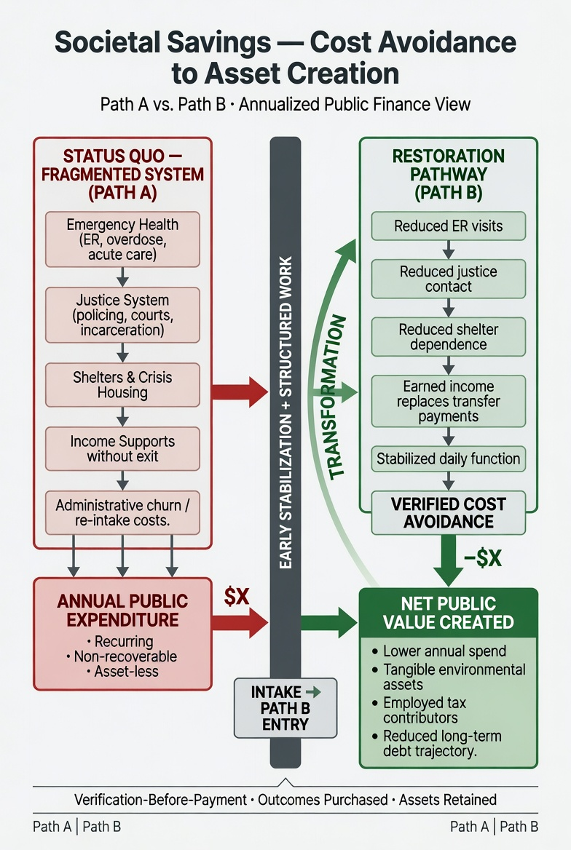
How the savings case works: Path A spending recurs every year; Path B avoids part of it and creates assets.
The seed and the next Godspring. The ask is $11.25M for Year 1, rising toward about $14.5M a year once return stays build up. This supersedes the earlier $3.5M figure (which covered roughly one cycle of food and clothing). The 10% reserve, $1.125M a year, funds the next camp. Each site seeds the next, which replaces the unsourced ×10 multiplier (Cascading Seed Model).

Open decisions
These must be closed before the spec goes to a funder as a costed proposal.
# | Decision | Why it matters | Owner
1 | Site. Cobalt/Coleman Crown land or an alternative | Sets transport, permits and the First Nations partner | Neil, with the Nation
2 | Medical partner. Mobile team or RAAM clinic | Condition of opening (section 6) | Neil
3 | Operator. Charity, non-profit or Nation-run entity | Decides who can receive the seed and issue receipts | Neil and advisors
4 | Year 1 Controllers. How many hired peer workers before graduates exist, and from which stream | 40 hires at ~$45K would take ~$1.8M of the $2.25M Operations stream | Operator
5 | Funder acceptance of the waterfall. Will a funder pay Community & Elders and the reserve, or only direct costs? | If only direct costs, the ask drops but nothing seeds the next camp | Funder conversation
6 | Earthworks contract revenue. Named sources (TRCA, municipal, provincial, federal green infrastructure) | Graduates need paid work to go to | Neil
7 | Gold tier canon change. Gold = Elder mentors aged 55+ | Canon and math manual need updating | Neil
8. User Area (supervised consumption). Section 56.1 exemption, operating under the medical partner, or opening without it. Owner: Neil, with the medical partner. This is the decision most likely to slow a provincial funder, so settle the route before you ask.
9. Operator and IP. Enter the MASH says HALO Co-op, worker- and graduate-owned. The government proposal says your sole proprietorship operates it and holds the IP. A government won't put $15M through a sole proprietorship. The likely route: a non-profit or co-op operates the camp, and you license the G.A.P.S. IP to it on written terms. Owner: Neil, with a lawyer.
10. Verification-before-payment needs an upfront tranche. If no money flows until outcomes are verified, the camp can't open. Ask for Year 1 operating funds up front, with later tranches tied to verified metrics. Owner: funder conversation.
11. The app. The $200,000–$250,000 MVP build isn't in the waterfall. Put it inside Year 1 Operations or ask for it separately. Owner: Neil.
12. Retreat map and DEEDSPROOF module. Write the week-by-week 3-Day Get-A-Way map for the 13-week stay, and complete the six DEEDSPROOF module fixes in section 4 before any graduate is matched to work. Owner: Neil.

Record of changes
What this spec changes from earlier MASH documents, and why.
Was | Now | Why
$7,500 per 4-month stay | $7,500 per 3-month stay | $80/day + $60/month = $7,380 for 90 days. The dollar figure was right; the 4-month label was wrong. Locked by Neil, Oct 18 2026
4-month stay (earlier draft of this spec, $10,000) | 3 months, with a one-month shadow overlap inside it | Newcomer's first month overlaps the senior's final month; same mentoring, no extra month of cost
$3.5M pilot ask | $11.25M Year 1 (about $14.5M with returns) | 600 people a year on the full waterfall; the old figure covered about one cycle of food and clothing
18.7:1 and 11.9:1 ROI claims | Break-even framing (23.4% at $80K) | Ratios assumed 100% of all costs avoided; break-even is checkable
"Paid participation" | Not waged at MASH; $22/hr starts at Earthworks | Conflicted with canon
Teens in some drafts | Adults 18+ only | Minors need a different legal and clinical framework
Medical support implied | Medical partnership is a condition of opening | Fatal withdrawal risk
Returns unbudgeted | 525 return stays a year inside the 200 beds, +$3.23M gross | Halving cascade; fits at about 96% occupancy
50-bed return node (earlier draft of this spec) | Removed | At 3-month stays, returns fit inside the main camp
Gold tier as high hourly pay | Gold = Elder mentors 55+ | Neil's correction; canon update pending
×10 seed multiplier | Cascading Seed Model (10% reserve) | Multiplier had no source

Fix before any earlier document is sent again
These lines are in the five source documents (Enter the MASH, the decision brief, white paper v3, the York Region pitch, and the Ontario proposal). Each one will cost you credibility with a reviewer who checks.
Claim | Where | Problem | Fix
"Supported by the Ontario Government" | Enter the MASH cover | No such support exists yet | Remove
"In partnership with" First Nations, the Catholic Church, CAEH, triOS, Georgian, Reaching Home | Several | Partnerships aren't signed | "Proposed partners" or "in discussion with"
"40 First Nations in network", "veto on traditional territory" | Enter the MASH, Ontario proposal | Not confirmed; speaks for Nations | Remove until a Nation agrees in writing
Budget totals $3.5M | Ontario proposal | Line items add to $3.75M once the $250K app line is included | Superseded by $11.25M
"$2M food and clothing × 3 cycles" | Ontario proposal | $2M covers about one cycle of 200; 600 people at $7,500 need $4.5M | Superseded
$72M Path A vs $65.5M saved, 18.7:1 | All except the pitch | Assumes 100% of all costs avoided for all 600 | Break-even framing
$44,000 wage, $8,800 tax | White paper v3, image | Canon is 1,500 h = $33,000; income tax at $33,000 is roughly $3,000 | Re-derive with an accountant
"$22/hr earned income on entry" | York Region pitch | MASH isn't waged | Remove
"Fixed camp, York Region" | York Region pitch | Canon site is Cobalt/Coleman | Align
"Academically validated" | Enter the MASH, Ontario proposal | SAF and OCI aren't validated yet | "Built on validated frameworks (CENAPS, MI, CRA)"
"Naming reduces amygdala activation by up to 50% (Siegel, 2012)" | Ontario white paper | The source is Lieberman et al. (2007); no "50%" figure | Cite Lieberman 2007, drop the percentage
Fish Bowl Method® "(pending)" | Ontario white paper | ® is only for registered marks | Use ™ until registered
"No police. No court." | Enter the MASH, white paper | See Safeguards | Use the incident line
"Lady, man, or youth" | Mission statement | Pilot is 18+ | Keep the motto, add "adults 18+" in the eligibility text
$120,000 sourced to "CIHI / Public Safety Canada / ESDC" | Mathematics Manual v2, Section 4 | Addendum could not trace those agency figures; $120K is also not the low end of the $105K–$130K range it cites | Three tracks: $120K Observed, $80K Conservative, $56K Evidence Floor (Latimer 2017)
"10-year value = $76,500 × 10 = $918,000" | Mathematics Manual v2, Section 5.1 | $76,500 × 10 = $765,000; $918,000 needs SRF = 2 | Correct to $765,000, or show SRF = 2
Land value 30–64% (Wharton); flood 6–10× (J. Hydrology / EPA / UNDRR) | Mathematics Manual v2, Section 4 | Addendum found 6% peer-reviewed, 17% and 30%; NIBS $6 per $1; UNDRR not located | Use the addendum figures
Simulation built on conservative published floors. Figures become evidence only when replaced by the pilot's measured outcomes.

